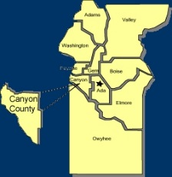
Canyon County Utility Coordinating Council
c/o 50 S Cole Rd.,
Boise, ID 83709
Canyon County UCC Meeting Notes – Wednesday 5-16-2018

- Pat opened at 12:00pm

- Cash in Bank: $ 1,278.26

- Minutes motioned to be accepted and seconded

Old business

Approved April minutes

New Business

August 1st change for Digline due date
Approved a $50 gift card for raffle at Golf Tourney for Specialty Construction Supply

Agency Reports:

Idaho Power :
  - Greenleaf power replacement

Intermountain Gas :
  - Tom, 44th and Stoffel new reg station
  - Brian, Valve season closing in the next 2 weeks

Digline
  - 1100 over last year, Canyon 20% over
  - Over 700 tickets 17-18 times so far
  - 27% online requests
T-O Engineers :
  - 2nd and 3rd in Nampa, 3 months to go
  - I-84 and Karcher overpass, end of summer
  - Midland Interchange

Williams :
  - Good

ELM :
  - Very busy. Working on communication with requestors.

Nampa Highway District :
  - Expectations and communications with utilities to move lines
  - Robinson and Victory roundabout started
  - Middleton and Orchard still in discussion
  - Chip sealing getting ready to start

Cable One :
  - Upgrading fiber
  - Finishing roundabout

City of Nampa :
  - Elijah drain culvert replacement next month

Das-Co :
  - Busy
  - Matthews road in Wilder, big job
  - Still doing Adelade replacement in Flamingo Mobile home park

adjourned at 1:02pm

