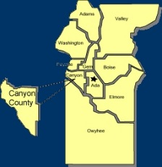
Canyon County Utility Coordinating Council
c/o 50 S Cole Rd.,
Boise, ID 83709
Canyon County UCC Meeting Notes – Wednesday 9-19-2018

- Opened at 12:00pm

- Cash in Bank: $ 1,278.26

- Minutes motioned to be accepted and seconded

Old business

ITD joining Digline discussion
Need more info on permit vs locate issues
New ticket due time discussion

New Business

ITD joining Digline discussion
Good things all around for new due times
Water and sewer laterals

Agency Reports:

Digline
Bringing in DPB notes and new rule info
10,000 over last year state wide
Canyon County 2000 over 2017 YTD
Moving to new location for the office

ELM :
  - Staffing issues and on time percentage

Das-Co :
  - Last push off Flamingo
  - Orchard and Farmway 2000’
  - Middleton and Ustick until December
  - Services

TO Engineers :
  - Downtown Nampa almost done
  - Force main by Munn Ranch sub to Greenleaf
  - Peckham rd scheduled for 2020

City of Nampa :
  - Greenhurst culvert and water, paving

Nampa Highway District :
  - Finishing round-a-bout at Robinson and Victory paving
  - Amity round-a-bout starting next year
  - Sent out plans for bridge and culvert replacements
  - Canyon Creek sub, water and sewer to new subdivisions

Track :
  - Canyon County slow on underground

IGC :
  - 12” Ustick 6-8 weeks
  - Bore interstate
  - Northside potholing
  - Greenhurst this winter

adjourned at 12:40pm

