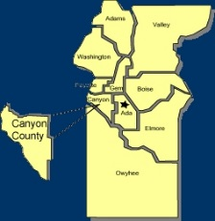
Canyon County Utility Coordinating Council
c/o 50 S Cole Rd.,
Boise, ID 83709
Canyon County UCC Meeting Notes – Wednesday 2-21-2018

- Pat opened at 12:04pm

- Cash in Bank: $ 1,807.48

- Jess motioned to accept January minutes, Juli second motion, all approved.

Old business

Alan Volbrecht from ELM Utility elected new CCUCC secretary/treasurer.

Follow up on the upcoming Contractors Breakfast. Asked for volunteers to bring in door prizes and handouts.

New Business

Brian Bettis nominated and voted to be the new CCUCC Vice President.

Agency Reports:

Idaho Power :
  - 15 damages for the month
  - 11 vehicle
  - 4 “other”
  - 0 “dig ins”

Intermountain Gas:
  - Damage prevention education

Digline
  - 893 requests in January, 384 last year
  - Positive Response Committee created
  - Changed what a “business day” means to match Idaho Law. Going in to effect around July 1st.

T-O Engineers :
  - 2nd and 3rd streets in Nampa, IMC starting in the middle of March
  - Sunroc doing Garrity and 11th
  - Franklin to Franklin I-84 still in planning

Williams :
  - Still slow for the next month

ELM :
  - Hiring and training, gearing up for another busy season

adjourned at 12: 37

