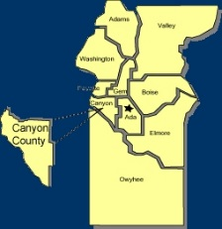
Canyon County Utility Coordinating Council
c/o 50 S Cole Rd.,
Boise, ID 83709
Canyon County UCC Meeting Notes – Wednesday 8-15-2018

- Opened at 12:00pm

- Cash in Bank: $ 1,278.26

- Minutes motioned to be accepted and seconded

Old business

Welcomed new guest Ethan Morgan with Idaho Power
New guest Tom Haynes with ITD
Talked about nominating someone from CCUCC to go to Joint States Meeting Oct. 2-3 in Vancouver
IUCC Avista Office Coeur d’Alene September 20-21
Discussion about Centurylink. Locates, damages, availability for disputes and repair time. Consistency on depth.
Discussion about permitting process as it relates to timeline of locates.

New Business

ITD joining Digline discussion
Need more info on permit vs locate issues
New ticket due time discussion

Agency Reports:

Digline
  - 8400 YTD last year, 10,250 YTD this year, 17% increase in canyon county, 13% state wide.

ELM :
  - Staffing discussion

Cable One :
  - Lots of smaller jobs
  - Busy

TO Engineers :
  - Simplot work
  - 2020 Peckham road 5.5 mile widening
  - 2nd and 3rd in Nampa around 1 month to completion

City of Nampa :
  - Not much

Williams :
  - Busy, upcoming projects
  - Franklin and Black Cat pipe
  - Star and Ustick replacement
  - New Plymouth and Payette pipe replacement

adjourned at 12:38pm

